Characters and Strings

1. Do not attempt to modify string literals

Ex 01:

Non-Compliant Code:

#include<stdio.h>
int main(){
char *str="string literals";
str[0]="S";
}

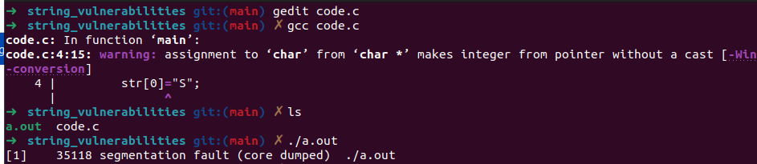
Here the string is stored in the text or the datasection read only portion of the memory layout and the pointer points to that address. Here we are trying to modify the data in readonly portions

Compliant Code:

#include<stdio.h>
int main(){
char str[] = "string literal";
printf("Before %s\n",str);
str[0] = 'S';
printf("After %s",str);
}
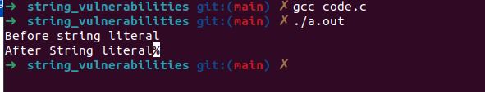
Here the string stored in readonly area text in process memory, but during the declaration of char array a copied in created in the stack frame where it is created.

Ex 02:

Non-Compliant Code:

#include<stdio.h>
#include<stdlib.h>

void func(void){
mkstemp("/temp/edXXXXXX");
}
int main(){
func();
}

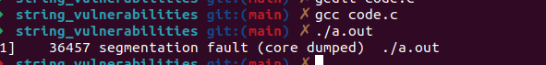
Here we mkstemp function try to modify the string literal, which is present in the readonly portion of the memory.

Compliant Code:

#include<stdio.h>
#include<stdlib.h>

void func(void) {
static char fname[] = "/tmp/edXXXXXX"; // Modifiable string
int fd = mkstemp(fname);
printf("Temporary file created: %s\n", fname);
close(fd); // Close the file descriptor
}

int main() {
func();
return 0;
}

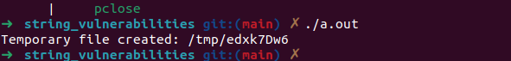

Here we are copying the string lliteral to a character array and then passing the mkstemp function

2. Guarantee that storage for strings has sufficient space for character data and the null terminator

Ex 01

Non-Complaint Code:

#include <stddef.h>

void copy(size_t n, char src[n], char dest[n]) {
size_t i;

for (i = 0; src[i] && (i < n); ++i) {
dest[i] = src[i];
}
dest[i] = '\0';
}

Here we dont have space to add null character, which voilates the secure coding proactive

Complaint Code:

#include <stddef.h>

void copy(size_t n, char src[n], char dest[n]) {
size_t i;

for (i = 0; src[i] && (i < n - 1); ++i) {
dest[i] = src[i];
}
dest[i] = '\0';
}

Here, we have added a null characher expliciltly and the end of the array .

Ex 02

Non-Complaint Code:

#include <stdio.h>

#define BUFFER_SIZE 1024

void func(void) {
// Variable to be overwritten
char a=”B”
char buf[BUFFER_SIZE];

printf("Before overflow: %c\n", a);
if (gets(buf) == NULL) {

}

printf("After overflow: %c\n", a);
}

int main() {
func();
return 0;
}

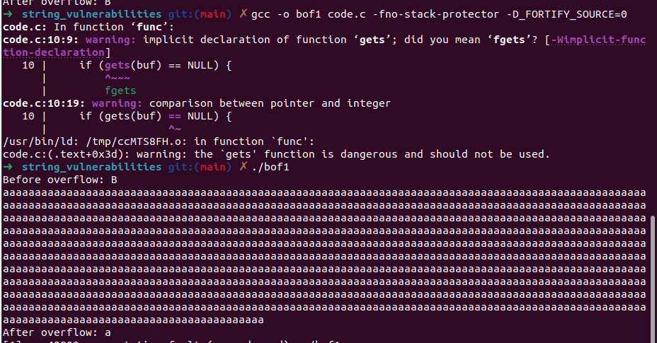
Here gets function dont have restriction on the size of input , which lead to buffer overflow attack.

Compliant Code:

#include <stdio.h>
#include <string.h>

enum { BUFFERSIZE = 32 };

void func(void) {
char buf[BUFFERSIZE];
int ch;

if (fgets(buf, sizeof(buf), stdin)) {
/* fgets() succeeded; scan for newline character */
char *p = strchr(buf, '\n');
if (p) {
*p = '\0';
} else {
/* Newline not found; flush stdin to end of line */
while ((ch = getchar()) != '\n' && ch != EOF)
;
if (ch == EOF && !feof(stdin) && !ferror(stdin)) {
/* Character resembles EOF; handle error */
}
}
} else {
/* fgets() failed; handle error */
}
}

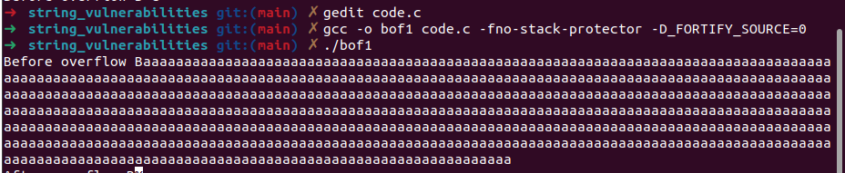

Here, even beyond 32 character it not caused overflow.

Other secure functions,

1. gets_s()
2. getline()

Ex 03:

Non-Compliant Code:

#include <stdio.h>

enum { BUFFERSIZE = 32 };

void func(void) {
char buf[BUFFERSIZE];
char *p;
int ch;
p = buf;
while ((ch = getchar()) != '\n' && ch != EOF) {
*p++ = (char)ch;
}
*p++ = 0;
if (ch == EOF) {
/* Handle EOF or error */
}
}

Here there is no limit on how many character to bet based on buffer size, Which might cause overflow

Compliant Code:

#include <stdio.h>

enum { BUFFERSIZE = 32 };

void func(void) {
char buf[BUFFERSIZE];
int ch;
size_t index = 0;
bool truncated = false;

while ((ch = getchar()) != '\n' && ch != EOF) {
if (index < sizeof(buf) - 1) {
buf[index++] = (char)ch;
} else {
truncated = true;
}
}
buf[index] = '\0'; /* Terminate string */
if (ch == EOF) {
/* Handle EOF or error */
}
if (truncated) {
/* Handle truncation */
}
}

Here if the input size becomes greater than 31 it terminates

Example 04

Non-Compliant Code:
#include <stdio.h>

enum { BUF_LENGTH = 32 };

void get_data(void) {
char a='B';
printf("Before overflow %c\n",a);
char buf[BUF_LENGTH];
if (1 != fscanf(stdin, "%s", buf)) {
/* Handle error */
}

/* Rest of function */
printf("After overflow %c",a);
}

int main(){
get_data();
}

Here no restriction on input size causes overflow

Compliant code:

#include <stdio.h>

enum { BUF_LENGTH = 32 };

void get_data(void) {
char a='B';
printf("Before overflow %c\n",a);
char buf[BUF_LENGTH];
if (1 != fscanf(stdin, "%31s", buf)) {
/* Handle error */
}

/* Rest of function */
printf("After overflow %c",a);
}

int main(){
get_data();
}

Restriction on input size to 31 charachets no overflow

Ex- 04: getenv()

Non-Compliant Code:

#include <stdlib.h>
#include <string.h>
#include<stdio.h>
void func(void) {
char a='A';
printf("Before overflow %c\n",a);
char buff[5];
char *editor = getenv("EDITOR");
if (editor == NULL) {
/* EDITOR environment variable not set */
} else {
strcpy(buff, editor);
}
printf("After overflow %c", a);
}

int main(){

func();
}

Here ther is no input bound check on the value from the env variable

Complant Code:

#include <stdlib.h>
#include <string.h>

void func(void) {
char *buff;
char *editor = getenv("EDITOR");
if (editor == NULL) {
/* EDITOR environment variable not set */
} else {
size_t len = strlen(editor) + 1;
buff = (char *)malloc(len);
if (buff == NULL) {
/* Handle error */
}
memcpy(buff, editor, len);
free(buff);
}
}

Ex 05 -argc

Non – Compliant Code:

#include<stdio.h>
#include<string.h>
#include<stdlib.h>

int main(int argc, char *argv[]) {
/* Ensure argv[0] is not null */
char a='B';
char prog_name[2];
printf("Before overflow %c\n",a);
const char *const name = (argc && argv[0]) ? argv[0] : "";

strcpy(prog_name, name);
printf("After overflow %c",a);
return 0;
}

Here if the program name or any command line argument are two large the it cases overflow

Compliant Code:

#include <stdlib.h>
#include <string.h>

int main(int argc, char *argv[]) {
/* Ensure argv[0] is not null */
const char *const name = (argc && argv[0]) ? argv[0] : "";
char *prog_name = (char *)malloc(strlen(name) + 1);
if (prog_name != NULL) {
strcpy(prog_name, name);
} else {
/* Handle error */
}
free(prog_name);
return 0;
}

3- Do not pass a non null terminated character sequence to a libarary function that expects a string

Ex 01

Non -Complaint Code:

#include <stdio.h>

void func(void) {
char c_str[3] = "abc";
printf("%s\n", c_str);
}

Since we specified the bound for the string literal and size of string euqal to input no space for null character.

Here the prgrame is not null-terminated to such a function can result in accessing memory that is outside the bounds of the object.

Complaint Code:

#include <stdio.h>

void func(void) {
char c_str[] = "abc";
printf("%s\n", c_str);
}

Here array bound is omitted, so here there is a chance the complier allocated sufficient memeory and adds null charachetre

Ex 02:

Non Complaint Code:

#include <stdlib.h>
#include <wchar.h>

wchar_t *cur_msg = NULL;
size_t cur_msg_size = 1024;
size_t cur_msg_len = 0;

void lessen_memory_usage(void) {
wchar_t *temp;
size_t temp_size;

/* ... */

if (cur_msg != NULL) {
temp_size = cur_msg_size / 2 + 1;
temp = realloc(cur_msg, temp_size * sizeof(wchar_t));
/* temp &and cur_msg may no longer be null-terminated */
if (temp == NULL) {
/* Handle error */
}

cur_msg = temp;
cur_msg_size = temp_size;
cur_msg_len = wcslen(cur_msg);
}
}

Here cur_msg is passed to wcslen without null termination

Compliant Code:

#include <stdlib.h>
#include <wchar.h>

wchar_t *cur_msg = NULL;
size_t cur_msg_size = 1024;
size_t cur_msg_len = 0;

void lessen_memory_usage(void) {
wchar_t *temp;
size_t temp_size;

/* ... */

if (cur_msg != NULL) {
temp_size = cur_msg_size / 2 + 1;
temp = realloc(cur_msg, temp_size * sizeof(wchar_t));
/* temp and cur_msg may no longer be null-terminated */
if (temp == NULL) {
/* Handle error */
}

cur_msg = temp;
/* Properly null-terminate cur_msg */
cur_msg[temp_size - 1] = L'\0';
cur_msg_size = temp_size;
cur_msg_len = wcslen(cur_msg);
}
}

Here it is null terminated

Ex 03

Non- Complinat Code

#include <string.h>

enum { STR_SIZE = 32 };

size_t func(const char *source) {
char c_str[STR_SIZE];
size_t ret = 0;

if (source) {
c_str[sizeof(c_str) - 1] = '\0';
strncpy(c_str, source, sizeof(c_str));
ret = strlen(c_str);
} else {
/* Handle null pointer */
}
return ret;
}

Here it is stncpy will not keep null in dst if there is no null in src

Compliant Code

#include <string.h>

enum { STR_SIZE = 32 };

size_t func(const char *source) {
char c_str[STR_SIZE];
size_t ret = 0;

if (source) {
strncpy(c_str, source, sizeof(c_str) - 1);
c_str[sizeof(c_str) - 1] = '\0';
ret = strlen(c_str);
} else {
/* Handle null pointer */
}
return ret;
}

Here we specift null after copying and then passing to strlen function.

4. Cast characters to unsigned char before converting to larger interger sizes

Ex 01

Non-Complinant Code:

static int yy_string_get(void) {
register char *c_str;
register int c;

c_str = bash_input.location.string;
c = EOF;

/* If the string doesn't exist or is empty, EOF found */
if (c_str && *c_str) {
c = *c_str++;
bash_input.location.string = c_str;
}
return (c);
}

Non-Compliant Code:

static int yy_string_get(void) {
register unsigned char *c_str;
register int c;

c_str = bash_input.location.string;
c = EOF;

/* If the string doesn't exist or is empty, EOF found */
if (c_str && *c_str) {
c = *c_str++;
bash_input.location.string = c_str;
}
return (c);
}

Compliant Code:

static int yy_string_get(void) {
register char *c_str;
register int c;

c_str = bash_input.location.string;
c = EOF;

/* If the string doesn't exist or is empty, EOF found */
if (c_str && *c_str) {
/* Cast to unsigned type */
c = (unsigned char)*c_str++;

bash_input.location.string = c_str;
}
return (c);
}

Ex 02

Non Compliant Code

#include <limits.h>
#include <stddef.h>

static const char table[UCHAR_MAX + 1] = { 'a' /* ... */ };

ptrdiff_t first_not_in_table(const char *c_str) {
for (const char *s = c_str; *s; ++s) {
if (table[(unsigned int)*s] != *s) {
return s - c_str;
}
}
return -1;
}

Compliant Code:

#include <limits.h>
#include <stddef.h>

static const char table[UCHAR_MAX + 1] = { 'a' /* ... */ };

ptrdiff_t first_not_in_table(const char *c_str) {
for (const char *s = c_str; *s; ++s) {
if (table[(unsigned int)*s] != *s) {
return s - c_str;
}
}
return -1;
}

5 Arguments to character -handling functions must be represntable as an unsigned char

Ex 01

Non Compliant Code:

#include <ctype.h>
#include <string.h>
#include<stdio.h>
size_t count_preceding_whitespace(const char *s) {
const char *t = s;
size_t length = strlen(s) + 1;
while (isspace(*t) && (t - s < length)) {
++t;
}
return t - s;
}

int main(){
const char signedString[] = "\xC0hello";

int res=count_preceding_whitespace(signedString);
printf("%d",res);
// here \xC0 is a negative ascii characher but isspace function opeates only in postive ascii characters
}

the isspace function requires an unsigned char

all character handling functions works in the range of unsiged char 0-255 is a signed char is bassed with ascii value greater than 127 the it will be interpreted as negative value which will lead to unusal behaviour.

Compliant Code:

#include <ctype.h>
#include <string.h>

size_t count_preceding_whitespace(const char *s) {
const char *t = s;
size_t length = strlen(s) + 1;
while (isspace((unsigned char)*t) && (t - s < length)) {
++t;
}
return t - s;
}

Before passing a argument to character handling functions it need to be changed to a Unsigned Char

6- Do not confuse narrow and wide character strings and functions

Non Compliant Code:

Wide string with narraow string funcitons

#include <stddef.h>
#include <string.h>
#include<stdio.h>
void func(void) {
wchar_t wide_str1[] = L"0123456789";
wchar_t wide_str2[] = L"0000000000";

strncpy(wide_str2, wide_str1, 10);
wprintf(L"Wide chrachter %lc\n",wide_str2);
}

int main(){
func();
}

Here strncpy cannot be used with wild character because strncpy works with 1 byte character size and it iternates till it reaches nulll chracter, but wchar_t operates with 2 or 4 bytes character size, where the null is also a part of character

Non-Compliant Code:

Narrow string with wide string function

#include <wchar.h>

void func(void) {
char narrow_str1[] = "01234567890123456789";
char narrow_str2[] = "0000000000";

wcsncpy(narrow_str2, narrow_str1, 10);
}

Here we should strncpy

Compliant Code:

#include <string.h>
#include <wchar.h>

void func(void) {
wchar_t wide_str1[] = L"0123456789";
wchar_t wide_str2[] = L"0000000000";
/* Use of proper-width function */
wcsncpy(wide_str2, wide_str1, 10);

char narrow_str1[] = "0123456789";
char narrow_str2[] = "0000000000";
/* Use of proper-width function */
strncpy(narrow_str2, narrow_str1, 10);
}

Here there is a proper use of wcsncpy and strncpy functions

Ex 02:

Non Compliant Code:

#include<stdio.h>
#include <stdlib.h>
#include <string.h>

void func(void) {
wchar_t wide_str1[] = L"0123456789";
printf("%d\n",strlen(wide_str1));
}
int main(){
func();
}

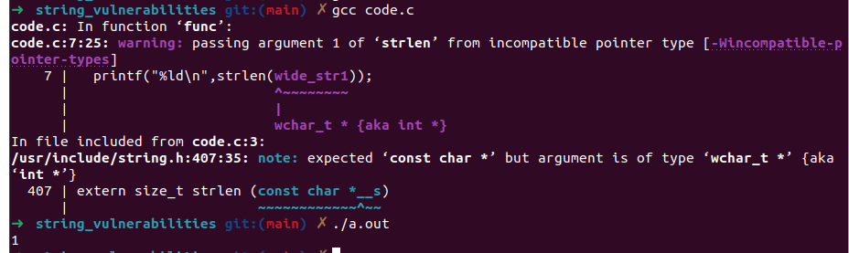

Here, proper function need to be used insted of strlen()

Compliant Code:

#include<stdio.h>
#include <stdlib.h>
#include <string.h>

void func(void) {
wchar_t wide_str1[] = L"0123456789";
printf("%d\n",wcslen(wide_str1));
}
int main(){
func();
}

